TEMPLATE TO ILLUSTRATE PAPER FORMAT FOR THE ATIS 2009 CONFERENCE PROCEEDINGS
(blank line)
I. M. Author¹ and U. R. Too²
(blank line)
¹Professor, Dept. of Materials Engineering, Indian Institute of Science,
Bangalore - 560012, India, atis2009@materials.iisc.ernet.in
²Graduate Research Assistant, Dept. of Materials Engineering, Indian Institute of Science,
Bangalore - 560012, India, too@materials.iisc.ernet.in (11-point type)
(blank line)

ABSTRACT
(blank line)
This template illustrates the format that must be used in the preparation of papers for ATIS 2009, the International Conference on Advances in Theory of Ironmaking and Steelmaking. Text and headings should be in Times New Roman (or similar) 11-point type. Included in this template are examples of headings, equation format, references, and other typographical features likely to be encountered in technical papers. The abstract should be an informative summary of the most important results. It should not include references, figures, or tables. The abstract is of utmost importance, because it is the most widely read portion of a manuscript. The maximum paper length is only eight pages.
(blank line)
KEY WORDS: Paper template, ATIS, Conference, Ironmaking, Steelmaking
(blank line)

1. Introduction
(blank line)
The flow of gas and liquids in the lower zone of the blast furnace are very complex (see Figure l). Liquid iron and slag drip from the cohesive zone, through the dripping zone to the blast furnace hearth. Hot air is introduced through the tuyeres at high velocity, causing the formation of a raceway or solid free void space. The gas velocity field in the dripping zone is highly non-uniform. Gas velocities are very high near the raceway and reduce markedly as the gas spreads through the coke bed.
(blank line before the figure)
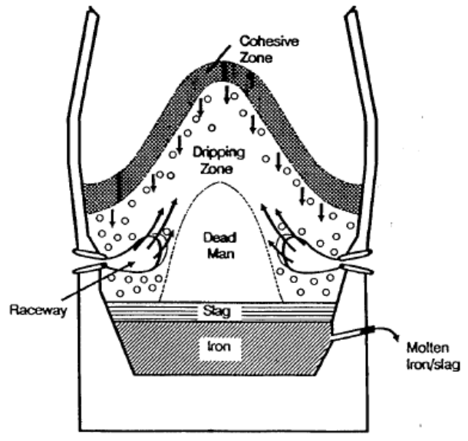
(blank line after the figure)
Figure 1: Schematic of the blast furnace lower zone.
(blank line after the figure caption)

Depending on position, the direction of gas flow can range from cross current to counter current with respect to the liquid flow. The operation of the blast furnace depends directly on the maintenance of smooth and stable operation in the dripping zone. Many researchers have attempted to analyse the raceway region (Niwa et al., 1990; Flint and Burgess, 1992) and dripping zone (Furutake and Rajakumar, 1980) employing various methods including cold and hot model studies at laboratory scale, on the plant measurement during the blast furnace operation, mathematical modelling and dissection of actual frozen blast furnaces.
(blank line before the paragraph)
Relatively little work has been done to understand the physical mechanisms of liquid flow in the dripping zone. Some work has been done on the liquid distribution in packed bed columns under wetting conditions. However, conditions in the dripping zone are generally considered to be non-wetting. Yagi (1993) provided a detailed review of mathematical models of complex multiphase flow applied to metallurgical applications, including the blast furnace.
(blank line)

2. THEORY
(blank line)
Structured packing helps in minimizing bed structure effects on the liquid flow, and the validation of the model is also easier under this assumption. X-ray radiography technique was used to visualize the liquid flow in a packed bed under the gas flow condition. The salient features of the gas-liquid flow model are described in the following section.
(blank line)
2.1 Modeling of gas flow
(blank line)
Gas was assumed to be interpenetrating continua and modeled using k-ε model for turbulent flow. The basic equations describing the gas flow are (Davidson, 2004):
(blank line)
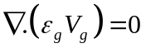 (1)
(blank line)
(2)
(blank line)
where, 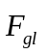 represents the gas-liquid interaction term and it is equal to (opposite in magnitude) the gas drag on liquid. All other symbols are defined in nomenclature given at the end of the paper.
(blank line)

3. Results and discussion
(blank line)
Table 1 gives the calculated raceway size used in the model. The computed liquid shift of iron and slag in presence of air when they are fed from the same nozzle together are shown in figure 2. Gas velocity is 70 m/s. The liquid (molten metal and slag) trickles down the porous coke matrix. The density of slag is lower than that of molten metal. Hence, one may expect larger shift in case of liquid slag (lower density) than molten iron (higher density) with the same gas drag. This means that slag will be pushed more towards the deadman region than molten iron. One might also expect a high liquid holdup in some of the regions around the raceway (mostly in counter-current conditions), because of high gas drag.
(blank line)
Table 1: Calculated raceway size for increasing and decreasing velocities.
Velocity (m/s) | Raceway size (cm)
Velocity (m/s) | Increasing | Decreasing
40 | 2.09 | 5.16
70 | 4.90 | 8.55
(blank line after table)
This uneven distribution of liquid metal and slag will affect the mass transfer and heat transfer operations in the lower part of the furnace. As a result of this uneven flow patterns, high local temperature gradients may exist in some parts of the furnace. The flow pattern of molten metal in the high temperature regions (lower zone of the blast furnace) will also dictate the amount of silicon transfer into the liquid iron.
(blank line before paragraph)
It should be emphasized that the above analysis is based on a 2-D model in a structured bed. Quantitatively, results may change in a three dimensional and random packing reactor such as blast furnace. However, the trend of the results will not change significantly.
(blank line before the figure)
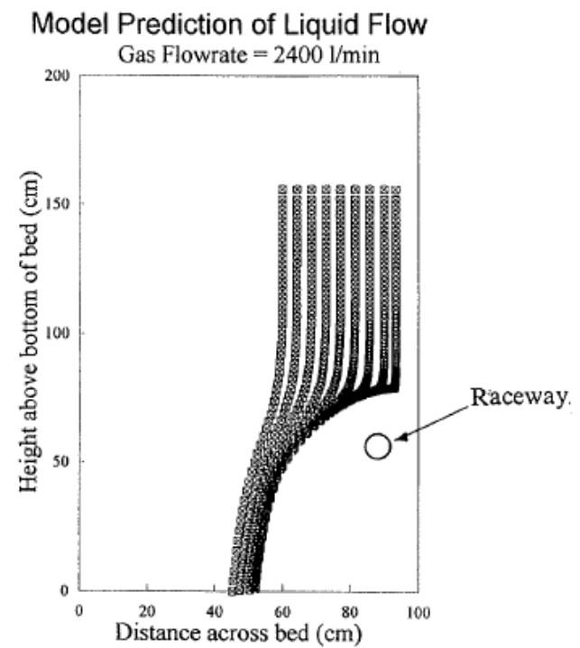
(blank line after the figure)
Figure 2: Predicted liquid flow within the raceway model (blast velocity=70 m/s).
(blank line)

4. Conclusions
(blank line)
A non-wetting liquid percolates through a packed bed as series of rivulets which are continuously breaking up and rejoining. The direction and magnitude of the percolation velocity is determined by the balance between three forces acting on the liquid-gravity, gas drag and bed resistance. Within our cold raceway model, the gas drag had a very strong effect on the liquid distribution, forcing the liquid away from the raceway region. At the bottom of the bed, the liquid flow was forced well away from the tuyere wall.
(blank line)
The mathematical model for liquid flow gave good agreement with experimentally observed liquid flow patterns in the cold raceway model. The effect of gas drag on the flow of liquid iron through the blast furnace lower zone should not be neglected.
(blank line)

5. Acknowledgements
(blank line)
We are grateful to BHP Ltd. for providing funding to perform this research. We also thank Mr. Peter Austin of BHP Research, Newcastle Laboratories for providing the numerical simulations of the gas flow field for the liquid flow modelling.
(blank line)

6. nomenclature
(blank line)
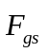 = Gas-solid drag force or interaction vector, (N)
= Gas-liquid drag force or interaction vector, (N)
= Acceleration due to gravity, (m/s²)
 = Gas pressure, (Pa)
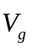 = Gas velocity vector, (m/s)
(blank line)
Greek Letters
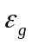 = Voidage for gas flow, (-)
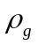 = Gas density, (kg/m³)
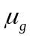 = Gas viscosity, (kg/m.s)
(blank line)

7. References
(blank line)
P. A. Davidson: Turbulence: An introduction for scientists and engineers, Oxford University Press (2004).
P. J. Flint and J. M. Burgess: Metall. Trans., 23B (1992), 267.
T. Furutake and V. Rajakumar: Tetsu-to-Hagané, 66 (1980), No. 13, 157.
Y. Niwa, T. Sumigama, A. Maki, S. Nagano, A. Sakai and M. Sakurai: Tetsu-to-Hagané, 76 (1990), No. 3, 31.
J. Yagi: ISIJ Int., 33 (1993), No. 6, 619.
(blank line)
BRIEF BIOGRAPHY OF PRESENTER
(blank line)
Please provide a brief biography of the presenting author here.

